Unit 3: The Natural World
Worksheet
Name: Date:
Animals and Habitats

Irregular Plural Nouns
Plural Nouns | Singular Nouns
people | person
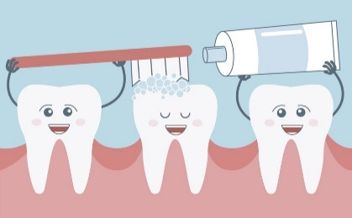
teeth | tooth
men | man
children | child
women | woman

ACTIVITIES
- Connect the singular nouns with their plural form.
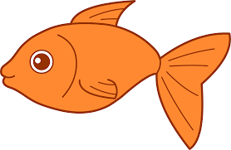fish wolves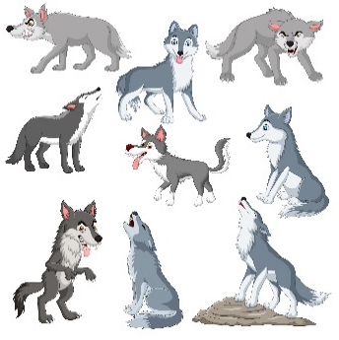
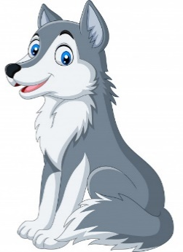wolf sheep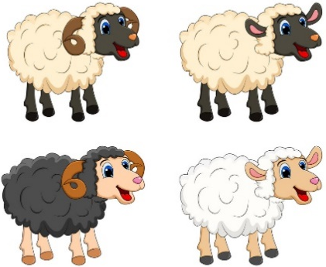

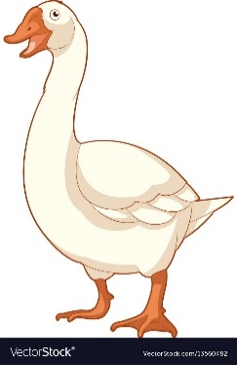 goose fish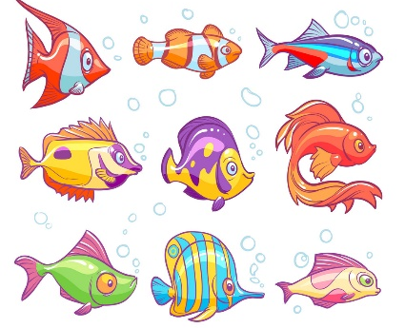

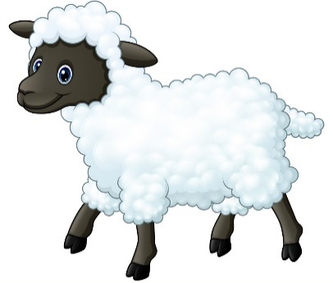 sheep geese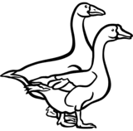

- Complete the following sentences choosing an alternative.

1. One man is wearing blue, and two ___________ are wearing green.
- Mens | - Man | - Men | - Mans

2. There are lots of _____________ at the library today
- Womans | - Women | - Womens | - Woman

3. How many ___________ are there in your family?
- Childs | - Child | - Children | - Childrens

4. I saw a flock of white __________ at the lake yesterday.
- Gooses | - Geese | - Geeses | - Goose

5. Look at all of the _______________ waiting in line for the movie!
- Persons | - Person | - People | - Peoples

6. I hope we don’t run into a pack of ____________ on our camping trip
- Wolves | - Wolf | - Wolfs | - Wolve

