Keeping with my students
Name:________________________________________________ Grade: 6th
Date: _________________________
In this first activity, you must answer a few questions about Mark’s routine video shown at the beginning of this lesson. The answers must be full answers. Example, Sacarias wakes up at 13:00 P.M.
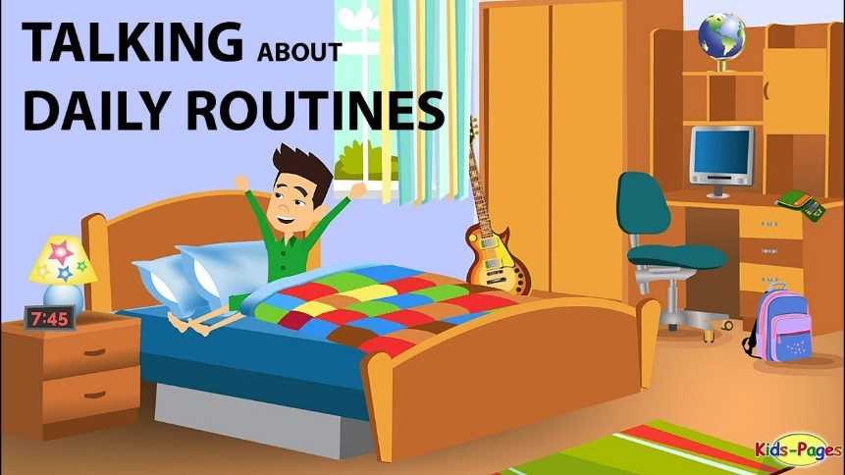
Mark’s daily routine
- What time does Mark get up?
________________________________________________________________________________________________________________________________________________________________
- What time does Mark have lunch?
________________________________________________________________________________________________________________________________________________________________
- What time does Mark get home?
________________________________________________________________________________________________________________________________________________________________
- What time does Mark have dinner?
________________________________________________________________________________________________________________________________________________________________
- What does Mark do on weekends?
________________________________________________________________________________________________________________________________________________________________
Nicole’s daily routine
- Why Nicole has breakfast just with her dad?
________________________________________________________________________________________________________________________________________________________________
- What time does Nicole have lunch?
________________________________________________________________________________________________________________________________________________________________
- What time does Nicole do her homework?
________________________________________________________________________________________________________________________________________________________________
- What does Nicole like to do before sleeping?
________________________________________________________________________________________________________________________________________________________________
- What does Nicole do at 5 PM?
________________________________________________________________________________________________________________________________________________________________

Now is your turn to talk about your daily routine! Answer the following questions and fill the blank watch with the correct hour of your daily activities.
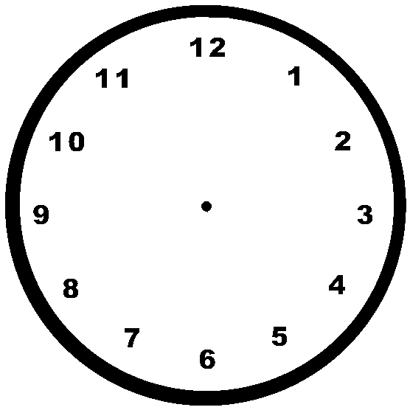
What time do you go to bed?

What time do you usually have lunch?

What time do you arrive home?
What time do you wake up?

