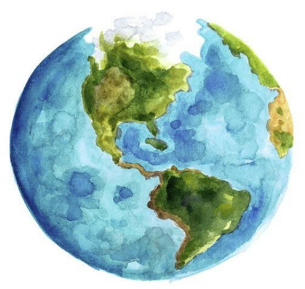

My planet, my responsibility.
Answer key
- Put the following sentences in the correct order. Make sure to use the grammar structure that has been presented at the beginning of the lesson.

- Is going to/ prove/ and/ waste/ pollution/ destruct/ atmosphere/ the/ more/ even/ ocean / the/ at
Pollution is going to destruct the atmosphere and provide even more waste at the ocean.
- effect/ will/ Greenhouse/ the/ increase/ temperature/ the/ in/ earth.
Greenhouse effect will increase the temperature in the earth.
- make/ Global warming/ of/ will/ planet/ our/ uninhabitable/ an/ humans/ for / place/high/ because/ temperatures./ of
Global warming will make of our planet an uninhabitable place for humans because of high temperatures.
- is going to/ the/ provide/ less/ space/ Deforestation/ for/ wildlife.
The deforestation is going to provide less space for wildlife.
- is going to/ Acid rain/ the/ plants/ planet./ decrease/ the/ variety/ in/ our/ of
Acid rain is going to decrease the variety of plants in our planet.
- Will/ affect/ ecosystem/ Species extinction/ to/ the/ because/ as/ such/ plagues/ mice, rats, and flies/ be/ even/ are going to/ frequent./ more
Species extinction will affect to ecosystem because the plagues such as mice, rats, and flies are going to be even more frequent.
- According to the following definitions, fill in the gaps with the most suitable word of the box down below
Acid rain – greenhouse effect – global warming – deforestation – pollution – species extinction

a)___greenhouse effect____ a gradual increase in world temperatures caused by gases such as carbon dioxide that are collecting in the air around the earth and stopping heat escaping into space.
b)____acid rain ______ rain that contains large amounts of harmful chemicals as a result of burning substances such as coal and oil.
c)____species extintion________ particular animal or plant species occurs when there are no more individuals of that species alive anywhere in the world - the species has died out.
d)____global warming _____ an increase in the amount of carbon dioxide and other gases in the atmosphere (= mixture of gases around the earth), that is believed to be the cause of a gradual warming of the surface of the earth.
e)____deforestation ______ the cutting down of trees in a large area, or the destruction of forests by people.
F)____pollution ______ damage caused to water, air, etc. by harmful substances or waste.

- Write a short sentence (30 words maximum) answering the next question.
Which one of the environmental problems mentioned before, in your opinion, is the most dangerous? How would it affect us in the future?
FOR EXAMPLE:
I think one of the biggest problems concerning to environmental problems will be air pollution. First, it is very dangerous, and we cannot breathe very well when the air is contaminated. In addition, as far as we know, air is essential for all lives in the planet.

